
National University of Technology

Machine Learning Lab- CS3504

LAB Submitted to:

Lec.Hajra Ahmad

Submitted By:
Muhammad Abdullah

Reg. No: F22607010
Batch: Fall AI 2022
Lab : 09
Q.NO.1:
- Create a dataset and write a Python program to implement the hierarchical
clustering algorithm using different linkage methods (single link, complete link,
group average and centroid method). Use Euclidean distance to calculate distance
between points. Also draw the proper graphs to graphically show the output of
Algorithm.
2. Change the distance metric in Task 1 to Manhattan Distance and compare the
results using graphs.
3. Cut the dendrogram at a specified distance to create the desired number of clusters (of your choice).
Answer:
import numpy as np
import matplotlib.pyplot as plt
import pandas as pd
from scipy.cluster.hierarchy import dendrogram, linkage, fcluster
from scipy.spatial.distance import pdist, squareform

# 1. DATASET CREATION
# Synthetic dataset with coordinates
data = np.array([
[2, 3], [3, 4], [4, 4], [5, 5],
[6, 8], [7, 9], [5, 2], [9, 10],
[4, 1], [8, 8]
])

labels = [f'P{i}' for i in range(1, len(data) + 1)]

# Function to plot the dendrogram
def plot_dendrogram(linkage_matrix, method, metric):
plt.figure(figsize=(10, 5))
dendrogram(linkage_matrix, labels=labels, color_threshold=6)
plt.title(f'Hierarchical Clustering using {method} Linkage ({metric} Distance)')
plt.xlabel('Data Points')
plt.ylabel('Distance')
plt.show()

# Function to apply clustering and plot dendrogram
def hierarchical_clustering(data, metric='euclidean'):
methods = ['single', 'complete', 'average']

if metric == 'euclidean':
methods.append('centroid')

for method in methods:
print(f"\nMethod: {method.capitalize()} Linkage ({metric.capitalize()} Distance)")
# linkage
linkage_matrix = linkage(data, method=method, metric=metric)
# dendrogram
plot_dendrogram(linkage_matrix, method=method, metric=metric)

# 2. TASK 1: EUCLIDEAN DISTANCE
print("### TASK 1: Using Euclidean Distance ###")
hierarchical_clustering(data, metric='euclidean')

# 3. TASK 2: MANHATTAN DISTANCE
print("\n### TASK 2: Using Manhattan Distance ###")
hierarchical_clustering(data, metric='cityblock')

# 4. CUTTING DENDROGRAM FOR DESIRED CLUSTERS
def cut_dendrogram(data, method, metric, num_clusters=3):
linkage_matrix = linkage(data, method=method, metric=metric)
clusters = fcluster(linkage_matrix, num_clusters, criterion='maxclust')
print(f"Clusters (Method: {method}, Metric: {metric}): {clusters}")

# Plot clusters
plt.figure(figsize=(8, 6))
plt.scatter(data[:, 0], data[:, 1], c=clusters, cmap='rainbow', edgecolors='k', s=100)
for i, label in enumerate(labels):
plt.text(data[i, 0], data[i, 1], label, fontsize=12, ha='right')
plt.title(f'Clusters (Method: {method}, {metric.capitalize()} Distance)')
plt.xlabel('X Coordinate')
plt.ylabel('Y Coordinate')
plt.show()

# Cutting Dendrogram for Single Linkage (Euclidean)
print("\n### Cutting Dendrogram for Desired Clusters ###")
cut_dendrogram(data, method='single', metric='euclidean', num_clusters=3)
cut_dendrogram(data, method='complete', metric='cityblock', num_clusters=3)

Output:
### TASK 1: Using Euclidean Distance ###

Method: Single Linkage (Euclidean Distance)
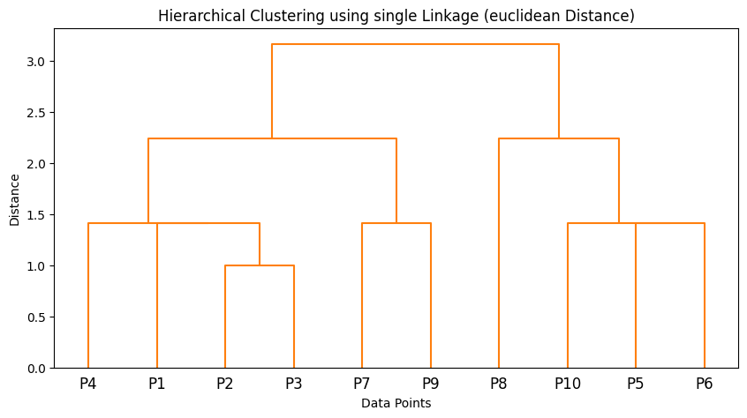

Method: Complete Linkage (Euclidean Distance)
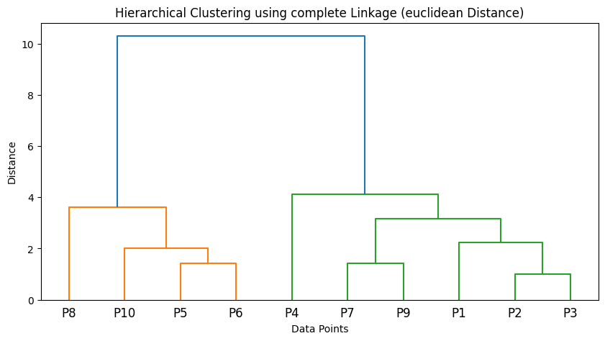
Method: Average Linkage (Euclidean Distance)

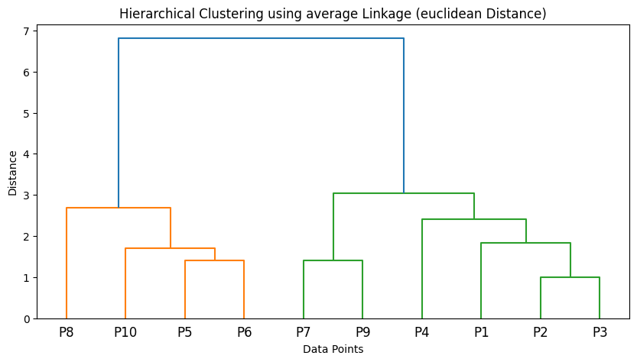

Method: Centroid Linkage (Euclidean Distance)
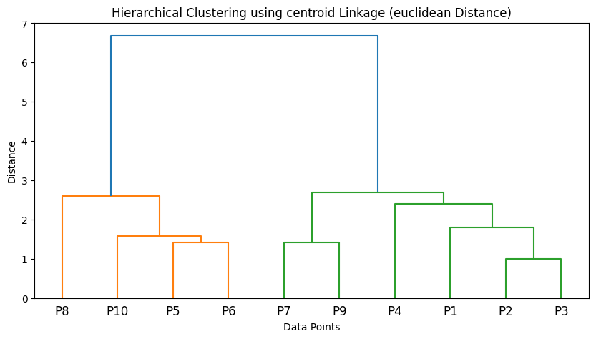
## TASK 2: Using Manhattan Distance ###

Method: Single Linkage (Cityblock Distance)
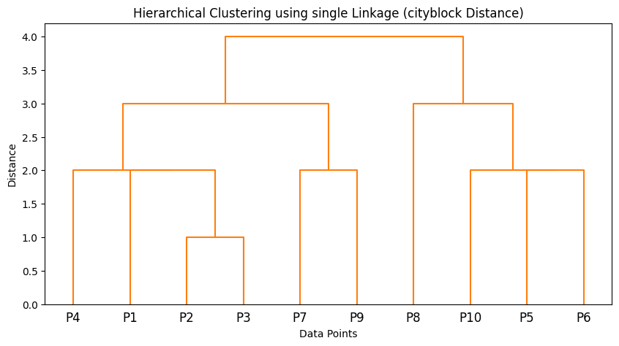

Method: Complete Linkage (Cityblock Distance)
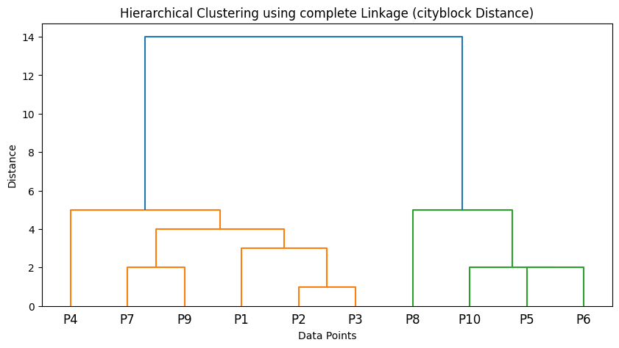

Method: Average Linkage (Cityblock Distance)
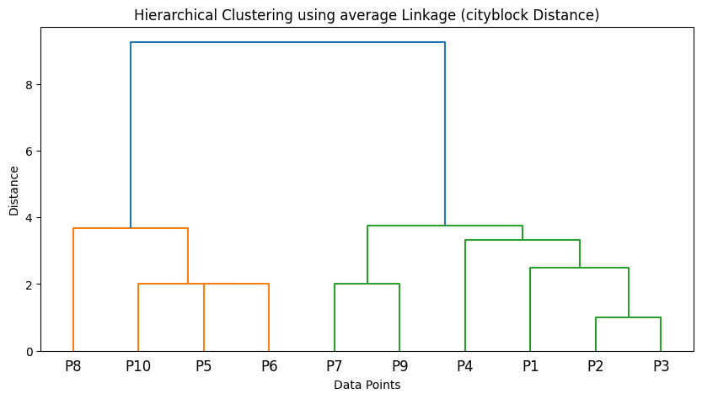
### Cutting Dendrogram for Desired Clusters ###
Clusters (Method: single, Metric: euclidean): [1 1 1 1 2 2 1 2 1 2]
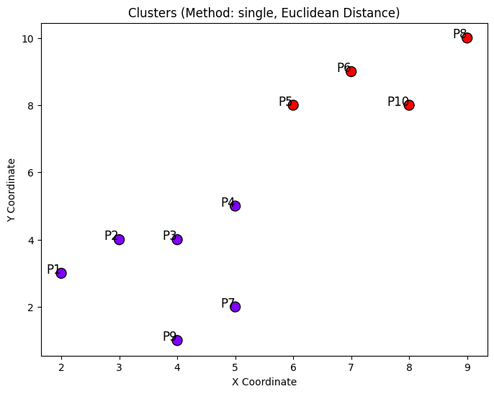

Clusters (Method: complete, Metric: cityblock): [1 1 1 1 2 2 1 2 1 2]



